**Experiment**

An experimental test setup to record the force produced by the leg, the current through the motors, and the position of the leg was constructed. In each trial, the platform performed a single jump starting from rest on a plate mounted to a load cell collecting force data. As the leg extends, a current sensor and motor encoders record the state of the motors.

High speed cameras track the motion of the robot body. The test is performed with several different leg designs chosen utilizing the simulation described above. The figure below shows the heights off the ground achieved by each of the leg designs.

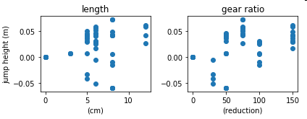

*Leg jump heights*

The electrical inputs to the motors and the mechanical output were also assessed in order to make a more detailed comparison between the legs’ behavior in simulation and experiment. The plot for one of the most successful designs is shown below as an example.

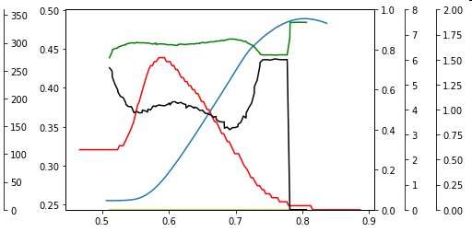

The electro-mechanical properties of the motor were then characterized and used to create a model of the motor in simulation. This model was then verified against an actual motor as shown below. This model can be incorporated into the overall leg model in order to improve its accuracy in comparison to the physical leg.

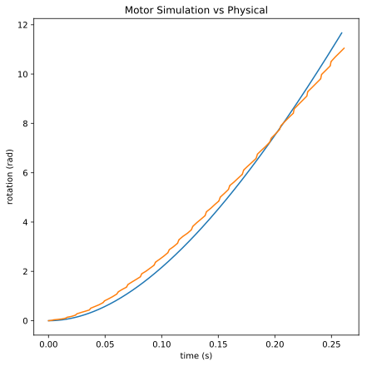

**Results & Discussion**

Comparing the experimental results with the simulation results shows that both simulations predict a higher jump height than either physical platform is able to achieve. Part of this error is due to the predicted mass of the platform for a given leg length not matching mass of the physical platform exactly. In order to remove this consideration, and assess the validity of the simulation models, the predicted masses used in the optimizations are updated with the measured masses of the legs. These masses are used to create the results shown in the table to the right, which are compared with the experimental results.

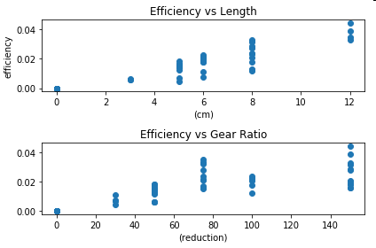

In spite of the measured masses being used in the simulation, even the multi-body simulation does not consistently match the experimental results. Several factors are thought to contribute to this. The first is that the flexibility of the leg members used in the simulation is only an approximation based on results for two different lengths of fiberglass and could be improved by measuring the stiffness of both physical platforms. Another factor is that the inertia of the motor and its gearbox used in the DC platforms is not included in the simulation and may pose a significant factor in hampering the acceleration of the leg.

Signature: Date: 2/28/18